附件1
主讲教授简介
王沛，女，中共党员，法学博士研究生毕业、法学博士学位、教授、研究生导师，河北省优秀中青年法学家。现为河北经贸大学法学院教授、河北省“八五”普法讲师团成员，从事国际法、国际刑法的研究和教学。
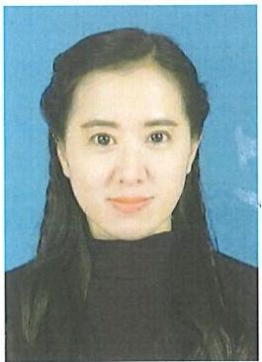
兼任河北省政府法制办专家、河北省检察院民事行政诉讼监督案件专家、中国法学会行为法学分会副秘书长、中国国际法学会会员，2016年被评为河北 省“三三三工程人才”、2020年被评为“河北省优秀中青年法学 家”,2018 2019年根据省“双千人才”计划在石家庄市正定人民法院挂职一年。
曾承担2022年9月商务部主办的“塞尔维亚国际产能合作各 类气体节能环保培训班”全英授课、承担2022年11月教育部主 办的尼泊尔企业管理“中国法律简介与投资管理中的风险防范” 全英授课，承担2022年5月商务部主办的“塞尔维亚产能合作法 律法规及公司制度海外培训班”全英授课，承担2021年“塞尔维 亚国际产能合作轧钢工艺技术培训班”全英授课，承担2019年11月中东欧“中国法律简介与投资风险”的全英授课。
WangPei, female, member of the Communist Party of China,born in June 1976. She is PhD of law and tutor, Outstanding Young and Middle-aged jurisprudential scholar in Hebei Province. Now she is a professor of the Law School of Hebei University of Economics and Business, and a member of the "Eighth Five-Year Plan" Lecture Group of Hebei Province. She is engaged in the research and teaching of international law and international criminal law.
She has been expert of the Hebei provincial government legislative affairs office , expert of Hebei province procuratorate civil administrative litigation supervision case, member of China international law society. She was named "333 engineering talent" in Hebei province in 2016, "outstanding middle-aged jurisprudential scholar" in Hebei province in 2020. She was assigned to Shijiazhuang Zhengding People's Court for one year from 2018 to 2019 according to the province "double thousand talents" plan.She has taken the Englishteaching for "Serbia international cooperation capacity of gas energy conservation and environmental protectiontraining" sponsored by the Ministry of Commerce in September 2022, the "Nepal enterprise management: China law introduction and risk prevention of investment management" sponsored by the Ministry of Education in November 2022,"Serbian Production Cooperation Laws and Regulations and Company System Overseas training" sponsored by the Ministry of Commerce in May 2022,"Serbia international production capacity of steel rolling technology training course" in 2021, the "Introduction to Chinese Law and Investment Risk" in Central and Eastern Europe in November 2019.

